Year 3
Mental Arithmetic
Test Questions

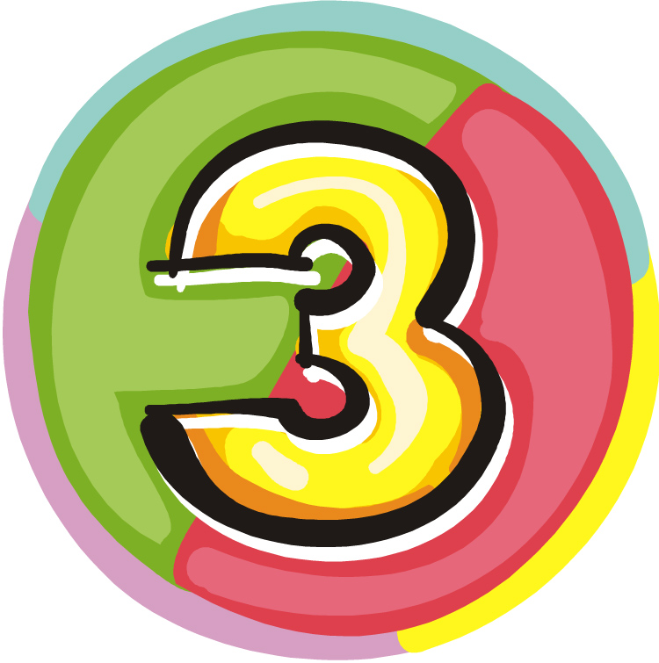

Equipment Required

- Printed question and answer sheet for the reader
- Printed blank answer page for child
- Stopwatch or timer
- Pencil

No other equipment is required to complete this test. No rulers, protractors or calculators should be used.

How to use the tests

Read out the text in red to the child. This tells them how long they have for each question.

Once you are ready to start, read out each question twice and then start the time (5 secs for the first 10 questions and 10 secs for the next 5 questions.

Although this is a mental maths test and the children should be doing the majority of working out in their heads, it is sometimes useful to write jottings down to help work out the answer. This is more than acceptable and good practice in case they need to go back (if they have spare time on one question) to finish working it out.

At the end of the test, mark the questions together and discuss how the child worked them out. Go through any they may have got wrong and work them out together.

Test 1

I will read every question twice. In this first set you will have 5 seconds to work out the answer and record it on your answer sheet.

1. Write the biggest number you can with these digits:
2, 5, 3 (532)
2. Round 95 to the nearest 10. (100)
3. What number is 10 less than 701? (691)
4. How many vertices has a pentagon? (5)
5. What must I add to 35 to make 100? (65)
6. Find the total of 4, 7 and 16. (27)
7. 12 children line up in 4 equal rows. How many children
are in each row? (3)
8. 4 children equally share 20 sweets. How many do they
get each? (5)
9. What is the next multiple of 5 after 195? (200)
10. How many diagonals has a square? (2)

For the next set of questions you will have 10 seconds to
work out the answer and record it on your answer sheet.

11. Linda has £5 in her money box. She spends £2.95 on
a book. How much does she have left? (£2.05)
12. What day of the week is 5th March 1999? (Friday)
13. Look at your sheet. Circle the fraction that is the same
as 0.5 .
¾ ¼ 1/3 ½ (½)
14. Write a number in each blank box so that the five
numbers are in order.

697

701
706

(698-700 inc.) (702-705 inc.)
15. Joe has 92 stamps. Sam has 47 fewer stamps. How
many stamps has Sam? (45)

YEAR 3 Mental Arithmetic Test 1

Name: Date:

1
2 5 3

2
11 £5
£2.95

12

3
701
Friday
12th
March
1999

4

5 35 100

6 4 7 16

13

3 1 1 1
4 4 3 2

7 12 children

4 rows

8 4 children

20 sweets

14
697 701 706

15 92 stamps

9 195
stamps 47

10

Test 2

I will read every question twice. In this first set you will have 5 seconds to work out the answer and record it on your answer sheet.

1. Write in figures the number eight hundred and six. (806)
2. Round 650 to the nearest 100. (700)
3. Put a ring round the smallest number:7, -1, 5, -8, 2 (-8)
4. If I am facing North and turn through 2 right angles, in
what direction will I be facing? (South)
5. Calculate the answer to 700 subtract 200. (500)
6. What is 200 more than 342? (542)
7. What is 900 divided by 10? (90)
8. Write the operation sign that would make the number
sentence correct. 18 ? 5 = 90 (x)
9. A large box weighs 1 kilogram and 350 grams. How
many grams is this altogether? (1350g)
10. Choose the best unit for measuring the length of a garden. km, m, cm - Ring the correct one. (m)

For the next set of questions you will have 10 seconds to
work out the answer and record it on your answer sheet.

11. How much water is in the jug? (300ml)
12. A box holds 6 eggs. How many boxes will hold 24
eggs? (4 boxes)
13. What is the least number of coins needed to make
28p? (4)
14. Tickets are £5 each. How many can you buy with £24?
(4)
15. Look at the sequence of numbers on your sheet. Write
the next number.
28, 23, 18, 13, 8

YEAR 3 Mental Arithmetic Test 2

Name: Date:

1 11

2 1 litre

3
7 -1 5 -8 2

4
North

500ml

ml

5
700 200

6 342 12

7 900

boxes

24 eggs

13
8
18 5 = 90

14

28p

£5 tickets

9 g 1kg 350g

tickets

£24

10

km m cm
15
28 23 18 13

Test 3

I will read every question twice. In this first set you will have
5 seconds to work out the answer and record it on your answer sheet.

1. What number is 100 more than 437? (537)
2. Write in figures the number six hundred and thirteen. (613)
3. Round 539 to the nearest 100. (500)
4. A watch costs between £6 and £7. How much might it have cost? (any amount from £6.01-£6.99 inc.)
5. If I am facing west and turn clockwise through ¾ turn, in what direction am I facing? (South)
6. Find the total of 16, 3, 5 and 7. (31)
7. Double 450. (900)
8. Put in the operation sign that would make the number sentence make sense. 63 ? 98 = 161 (+)
9. 1 pen costs 75p. What is the cost of 4 pens? (£3)
10. Write two pounds and seven pence using the £ sign and decimal point. (£2.07)

For the next set of questions you will have 10 seconds to work out the answer and record it on your answer sheet.

11.What measurement is shown by the scales? (4½kg or
4.5kg)
12.If 75 sweets are shared between 10 children, how many sweets will be left over? (5)
13.Look at the number line on your sheet. Draw an arrow to show where 2 ¾ is.

0 1 2 ↑ 3 4
14.I think of a number, double it and add 6. The answer is 36. What was my number? (15)
15.Write the missing number in the empty box in the sequence on your sheet.
5, 9, ?, 17, 21 (13)
YEAR 3 Mental Arithmetic Test 3

Name: Date:

1 11

2 2 3
1 4
3 539
0 5

4 kg

5 kg
West

6 16 3
7 5

7 450
12 75 sweets

10 children

13

8
63 98 = 161
0 1 2 3 4

14
36

9 75p
4 pens
15
5 9 17 21

10
£

Test 4

I will read every question twice. In this first set you will have 5 seconds to work out the answer and record it on your answer sheet.

1. Write in figures the number one thousand five hundred and six. (1506)
2. Write 193 to the nearest hundred. (200)
3. What number comes immediately before 560? (559)
4. On your sheet is part of a 100 square. Fill in the missing number.

23
34
45

5.What number is halfway between 300 and 400? (350)
6.How many faces has a triangular prism? (5)
7.What is 600 and 400 altogether? (1000)
8.Put a ring round the number that is a multiple of 5: ( 16, 20, 51, 59) (20)
9. Write in the operation sign that would make the number sentence correct 150 ? 21 = 129 (-)
10.How much time is between 8am and 3pm? (7 hours)

For the next set of questions you will have 10 seconds to work out the answer and record it on your answer sheet.

11. What temperature is shown on the thermometer? (37°C)
12. I have 36 cakes. How many boxes will I need to hold the cakes if one box holds 5 cakes? (8)
13. Four quarters and two halves make how many wholes? (2)
14. What is the total of 13, 3, 5 and 7? (28)
15. The pictogram on your sheet shows information about how many children in a school had a computer at home. The picture of the computer stands for 2 children. How many children in Y4 have a computer at home? (8)
YEAR 3 Mental Arithmetic Test 4
11 | 0
11 |  | °C

Name: Date:

1

2
193

3

12 36
4 cakes
23
45

13
wholes

5 14 13 3
7 5

6

7 600 400

8
16 20 51 59
9 | 150 |  | 21 = 129

Y4

Y3

Y2

Y1
 |  |  | 
 | 
 |  | 
 | 

Number of children

 = 2 children

10 8am
3pm

